TRANSMISSION LINES & WAVEGUIDES
EXPERIMENT – 3
DESIGN OF A QUARTER-WAVE TRANSFORMER
Student Name | Register Number | Date
K. MONISHA | 192412296 | 14.10.2026

AIM
To design a quarter-wave transformer for matching an input impedance (Zin) to a load impedance (ZL), and to study the effect of varying frequency and input impedance on transformer length and characteristic impedance.

SOFTWARE REQUIRED
SCILAB

FORMULAE
Characteristic impedance of the quarter-wave transformer: Ro = sqrt(Zin × ZL)
Wavelength: λ = c / f, where c = 3 × 10^8 m/s
Quarter-wave transformer length: L = λ / 4 = c / (4f)

PROCEDURE
- Open SCILAB software.
- Select File → New.
- Enter the program and input values.
- Execute the program.
- Observe the calculated transformer impedance and quarter-wave length.

TEST CASE 1: VARYING FREQUENCY
Given: Zin = 50 Ω, ZL = 100 Ω; operating frequencies = 100, 200, 300 and 500 MHz.
Ro = sqrt(50 × 100) = 70.7107 Ω.

PROGRAM (SCILAB)
clc;
clear;
close;
// Test Case 1: Fixed input and load impedances; vary frequency
Zin = 50;
ZL = 100;
f_values = [100 200 300 500]; // MHz
Ro = sqrt(Zin * ZL);
printf("Test Case 1: Zin = %g ohms, ZL = %g ohms\n", Zin, ZL);
printf("Transformer characteristic impedance Ro = %.4f ohms\n\n", Ro);
printf("Frequency (MHz)\tLength of lambda/4 transformer (m)\n");
for k = 1:length(f_values)
f = f_values(k) * 10^6; // convert MHz to Hz
lambda = 3 * 10^8 / f;
L = lambda / 4;
printf("%g\t\t%.4f\n", f_values(k), L);
end

CALCULATED RESULTS
Frequency (MHz) | Wavelength λ (m) | Quarter-wave length λ/4 (m) | Ro (Ω)
100 | 3.0000 | 0.7500 | 70.7107
200 | 1.5000 | 0.3750 | 70.7107
300 | 1.0000 | 0.2500 | 70.7107
500 | 0.6000 | 0.1500 | 70.7107

OUTPUT SCREENSHOT – TEST CASE 1
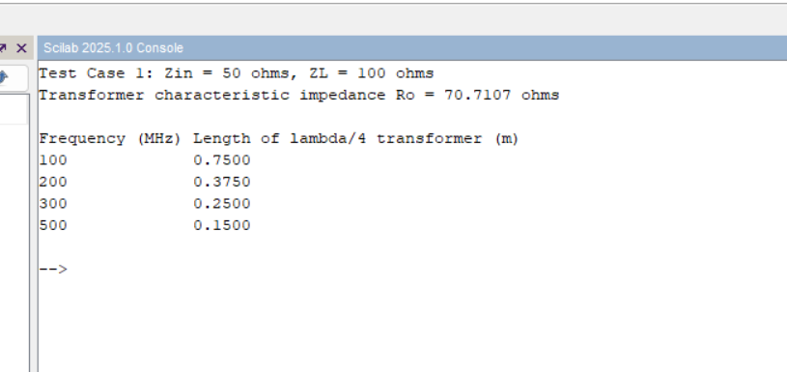

TEST CASE 2: VARYING INPUT IMPEDANCE
Given: f = 2 GHz, ZL = 100 Ω; Zin = 25, 50, 75 and 100 Ω.
At 2 GHz, λ = 0.1500 m and the quarter-wave length is λ/4 = 0.0375 m.

PROGRAM (SCILAB)
clc;
clear;
close;
// Test Case 2: Fixed frequency and load impedance; vary input impedance
f = 2 * 10^9; // Hz
ZL = 100;
Zin_values = [25 50 75 100];
lambda = 3 * 10^8 / f;
L = lambda / 4;
printf("Test Case 2: Frequency = 2 GHz, ZL = %g ohms\n", ZL);
printf("Quarter-wave transformer length = %.4f m\n\n", L);
printf("Zin (ohms)\tRo (ohms)\n");
for k = 1:length(Zin_values)
Zin = Zin_values(k);
Ro = sqrt(Zin * ZL);
printf("%g\t\t%.4f\n", Zin, Ro);
end

CALCULATED RESULTS
Zin (Ω) | ZL (Ω) | Ro = sqrt(Zin × ZL) (Ω) | Quarter-wave length (m)
25 | 100 | 50.0000 | 0.0375
50 | 100 | 70.7107 | 0.0375
75 | 100 | 86.6025 | 0.0375
100 | 100 | 100.0000 | 0.0375

OUTPUT SCREENSHOT – TEST CASE 2
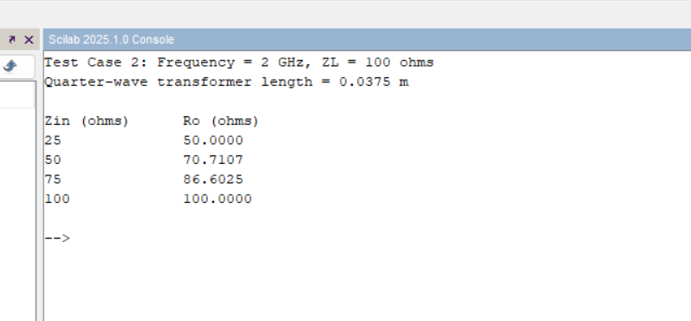

RESULT
A quarter-wave transformer was designed for Zin = 50 Ω and ZL = 100 Ω. The transformer characteristic impedance is 70.7107 Ω. As frequency increases, the quarter-wave length decreases. With f = 2 GHz and ZL = 100 Ω, the transformer characteristic impedance increases with Zin according to Ro = sqrt(Zin × ZL), while the quarter-wave length remains 0.0375 m.

